Figure 1 Double-beaded Model of Innovation Promotion

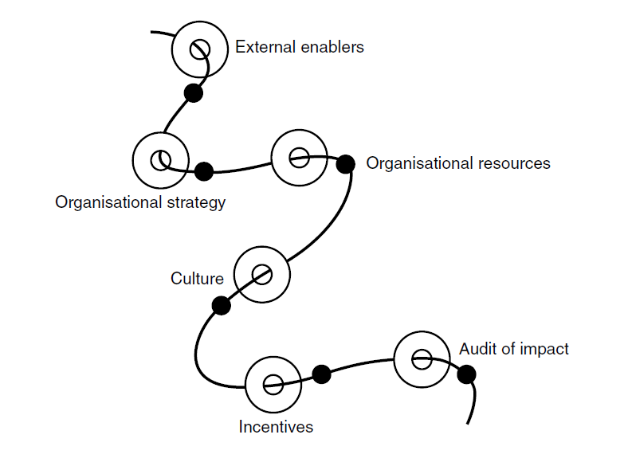

Table 1 Innovation Strategy - Heuristic framework

Systems | Behavioural | Problem-based | Opportunistic | Other
Policy | Individual | Prioritisation | Opportunity | Mixed mode
Strategy | Team | Research | Demand | Organic
Investment | Profession | Options | Research | Natural
Resources | Job | Appraisal | Plan | Unintended
Business plan | Performance | Solution | Action | Accidental
Objectives | Outcomes | Action | Outcomes
Action |  | Outcomes
Outcomes

