Figure 1: the vision for a mobile healthcare organisation

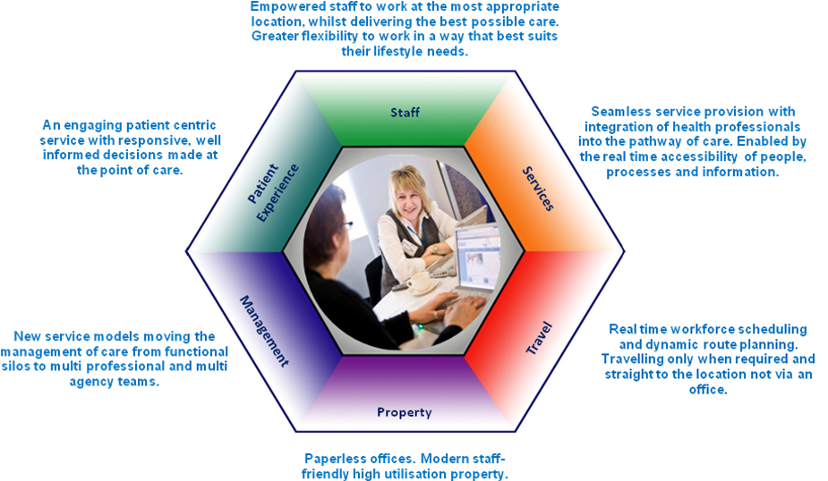

Figure 2: the mobile working journey

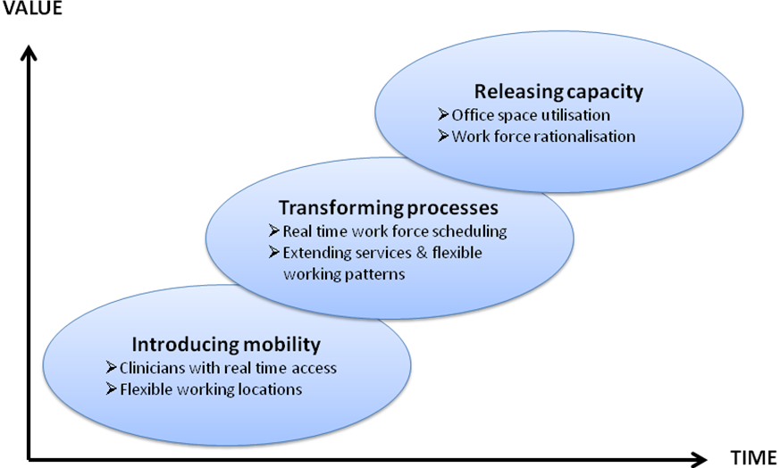

Figure 3: what you need to get right

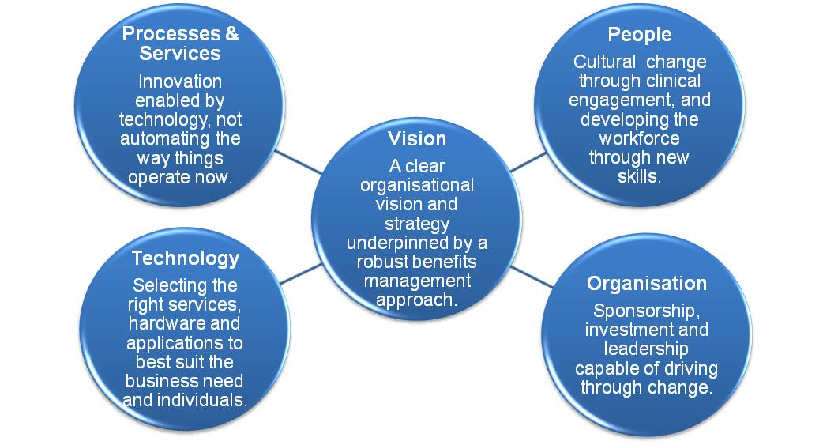

Figure 4: key features of the NHS Mobile Working Knowledge Centre
