Risk Stratification attached models

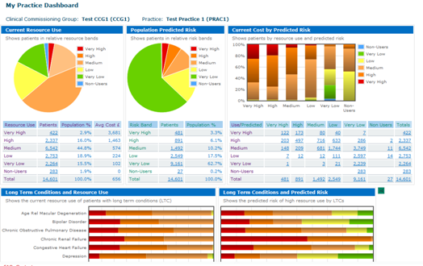

**1The Risk stratification tool data dashboard screen**

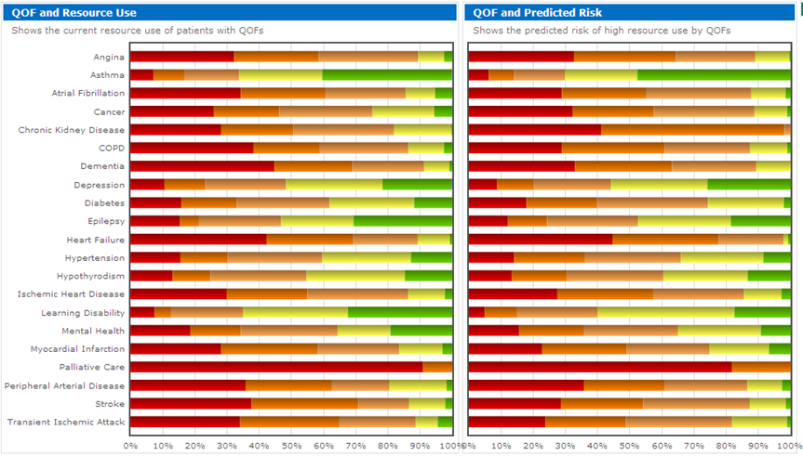

**2 Leeds QoF registers:** **It is now possible to view the current expected and predicted resource use**



**3 The risk stratification tool filtering screen: Patients can be filtered by ‘Long Term Condition’, `Major Disease Group` etc.**

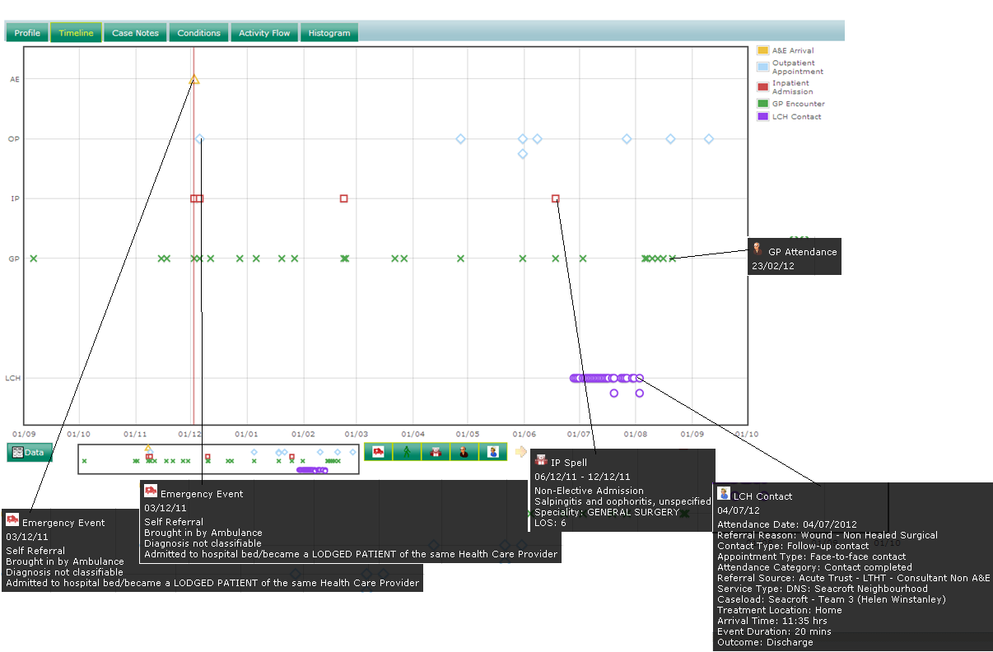

**4Timeline detailing patient encounters over a twelve month period with primary and secondary care**